
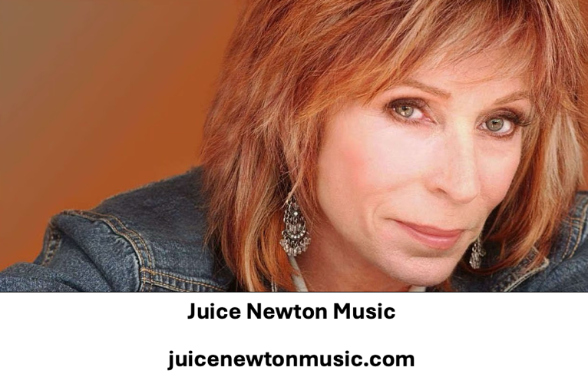

Summer Newsletter
2007

Hi Everyone,

This has been an incredible summer at JNM and with the letters of love and support for Juice. We cannot feel anything but gratitude. Thank you everyone, Juice sincerely appreciates all of her fans!

DIRTY LOOKS ON CD!

The year was 1983, a new album entitled “Dirty Looks” was released with the singles “Tell Her No” and the title cut.

This album contained much of Juice’s rock and roll influence. Since the invention of the compact disk and digital sound, the JNFC has received many inquires for this album to be available on CD format.

So, it is with great pleasure that I announce to all of you, this has now come to pass. ‘Dirty Looks’ is now available on CD and has been re-mastered to sound even better!! This CD release is from the same record company that released “Juice” & “Quiet Lies” on one CD last year. The record label is Raven Records from Australia.

This CD contains both the “Dirty Looks” and “Old Flame” albums. You may purchase your copy of this great item at Amazon.com and other retailers. Get it now!

NOTE: All of Juice’s albums from the 1980’s are now on CD.

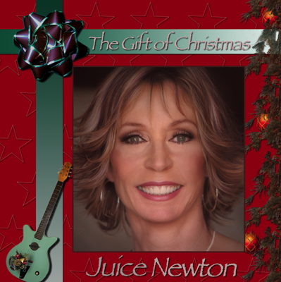
NEW CD
1) Go Tell It On The Mountain
2) Jingle Bell Rock
3) The First Noel
4) For Believers
5) Sleigh Ride
6) Santa Can Dance
7) Christmas Needs Love
8) Mary’s Boy Child
9) Shining Star
10) Better Get Ready
11) Christmas Wish
12) Auld Lang Syne

Juice’s Christmas CD will be available this fall! The exact date will be posted on the JNFC website and the Fall Newsletter when it become available!

Juice puts holiday cheer into these songs and the traditional carols sound a-new and the new songs are standards in the making. Juice & Otha Young and Andre Mayeux wrote most of the new songs. The songs they have written will be outlined in the Fall Newsletter.

More on this sensational CD is forth coming so please, STAY TUNED!

WEBSITE ENHANCEMENTS

The JNM website has upgraded with an all new Discography and Quicktime formatted movie of Juice’s albums. The blog is still forth coming. I had planned to have it up and running by now. Unfortunately, due to circumstances beyond my control, I have not been able to get this accomplished as of yet.

JNFC WANTS TO KNOW

Which album of Juice’s is your favorite and why? You can write up and paragraph and mail or email your document. All entries will be in the Holiday Newsletter and on the website.

Paul’s Favorite Album

“Choosing a favorite album of Juice’s, is like eating one potato chip, it is nearly impossible.

The albums ‘Juice’ and ‘Old Flame’ are my all time favorites. The reason being they both had similar personalities and spun off many hits. It was the character of the albums that made them so unique.

Juice puts so much emotion into the songs she interprets. You can hear this in ‘The Sweetest Thing (I’ve Ever Known)’ and ‘Hurt.’ Both albums were totally enjoyable and made me feel the emotions Juice was singing. That is why they are both my all time favorite.”

JNFC FANS ARE THE BEST!

As you all know, I had mailed out a request per Juice, to all of you. The request was to choose 2 to 3 of your favorite songs Juice has recorded throughout her career. The response on this project was outstanding!

Correspondence included: “The Sweetest Thing” & “Shelter of Your Love” and “’Til I Loved You” just to name a few!!

I have compiled all the information and have submitted it to Juice and Otha Young.

Thank you all for being the best fans a recording artist could ever hope for!!

ALL OF IT

That will do it for this newsletter. Do not forget to visit both juicenewtonmusic.com or up to date information on Juice. This includes her new Christmas CD! The Fall Newsletter will feature this new CD and song writers! You do not want to miss it!!

All the best,

Paul, Juice and Otha

